**Project Design Phase-II**

**Technology Stack (Architecture & Stack)**

|  |  |
| --- | --- |
| Date | 03 November 2022 |
| Team ID | PNT2022TMID25975 |
| Project Name | Project - Gas Leakage monitoring & Alerting system for Industries |
| Maximum Marks | 4 Marks |

**Technical Architecture:**

The Deliverable shall include the architectural diagram as below and the information as per the table1 & table 2

Guidelines:

1. Include all the processes (As an application logic / Technology Block)
2. Provide infrastructural demarcation (Local / Cloud)
3. Indicate external interfaces (third party API’s etc.)
4. Indicate Data Storage components / services
5. Indicate interface to machine learning models (if applicable)

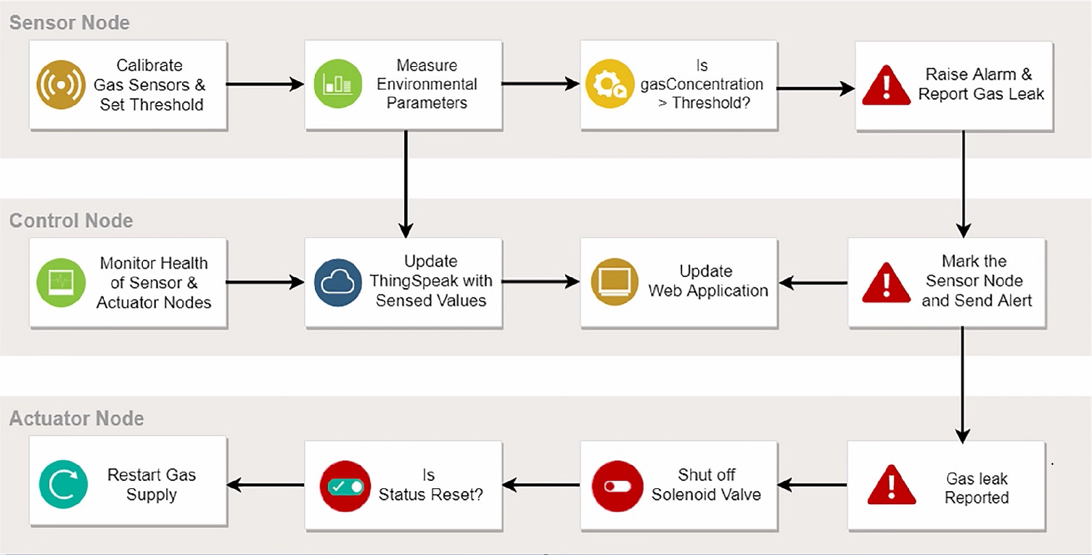

**Table-1 : Components & Technologies:**

|  |  |  |  |
| --- | --- | --- | --- |
| **S.No** | **Component** | **Description** | **Technology** |
|  | User Interface | Web application | HTML, CSS, Python |
|  | Application Logic-1 | Logic for a process in the application | Python |
|  | Application Logic-2 | Logic for a process in the application | IBM Watson STT service |
|  | Application Logic-3 | Logic for a process in the application | IBM Watson Assistant |
|  | Database | Data Type, Configurations etc. | MySQL, Database |
|  | Cloud Database | Database Service on Cloud | IBM Cloud |
|  | File Storage | File storage requirements | IBM Block Storage , Local Filesystem |
|  | External API-1 | Purpose of External API used in the application | IBM Weather API, etc. |
|  | External API-2 | Purpose of External API used in the application | Aadhar API, etc. |
|  | Machine Learning Model | Purpose of Machine Learning Model | Infrared Image Technology. |
|  | Infrastructure (Server / Cloud) | Application Deployment on Local System / Cloud  Local Server Configuration:  Cloud Server Configuration : | Local, Zigbee. |

**Table-2: Application Characteristics:**

| **S.No** | **Characteristics** | **Description** | **Technology** |
| --- | --- | --- | --- |
|  | Open-Source Frameworks | Leaks indicators developing ,electronics radar | Feed actual time sensor data internet |
|  | Security Implementations | Increasing due to an attack surface having data  Leakage detection in place a key. | Continuous monitor your external  attack surface. |
|  | Scalable Architecture | Requirements necessity for detection | BM Watson,Firebase,Mysql. |
|  | Availability | High quality instruments that can locate the leaks | Effective coding and restrictive user  access based on need |
|  | Performance | Sensor response time will be fast | Flask |

**References:**

[**https://www.researchgate.net/publication/361562550_Gas_Leakage_Detector_and_Monitoring_System**](https://www.researchgate.net/publication/361562550_Gas_Leakage_Detector_and_Monitoring_System)

[**https://www.researchgate.net/publication/347495607_Gas_leakage_detection_and_alerting_system_using_Arduino_Uno**](https://www.researchgate.net/publication/347495607_Gas_leakage_detection_and_alerting_system_using_Arduino_Uno)